|  |  |
| --- | --- |
| **Topic** | Volt Active Data |
| **Document Name** | VOLTDB-EX-03 |
|  |  |

|  |  |  |  |
| --- | --- | --- | --- |
| **Document Difficulty Level** | | | |
| **Beginner** | **Junior** | **Senior** | **Expert** |
| □ | ■ | □ | □ |

# Document History

|  |  |  |  |
| --- | --- | --- | --- |
| Date | Author | Ver | Comments |
| **05.03.2025** | Mennan Tekbir | 1.0 | Initial Draft |
| **05.03.2025** | Mehmet Erdem Önal | 1.1 | Revisions |

# Volt Active Data

## Exercise VOLTDB -EX-03:

**Definiton:** Connect VoltDB instance that you have created in the *VOLTDB -EX-03* exercise from [DBeaver](https://dbeaver.io/download/" \t "_blank). In order to connect VoltDB from DBeaver, you should create a new database driver ( Database → Driver Manager menu ) and download VoltDB client jar from maven [repo](https://mvnrepository.com/artifact/org.voltdb/voltdbclient" \t "_blank). Create sample table and insert some rows as shown below. Please also connect VoltDB [UI](http://localhost:55004/" \l "s" \t "_blank) from 55004 port ( you can inspect port mappings via docker ps command. )

**Note:** If you did not get a cloud machine previously, you may simply run it on your local machine.

**Sample Table Creation, and Row Insertion:**

create table mth3902 (

id bigint not null,

start\_date\_epoch bigint,

create\_user varchar(32),

constraint mth3902\_pk primary key(id)

);

partition table mth3902 on column id;

--- dr table mth3902;

insert into mth3902 ( id, start\_date\_epoch, create\_user ) values ( 1, 1698295044, 'MENNAN');

insert into mth3902 ( id, start\_date\_epoch, create\_user ) values ( 2, 1698295088, 'ERKUT');

select \* from mth3902 limit 1;

**Connecting to VoltDB**

sqlcmd --servers=localhost --port=21212

**Hint:** [Voltdb Quick Start](https://www.youtube.com/watch?v=1EkWP6Gu3VY" \t "_blank)

**DBeaver Driver Setup**

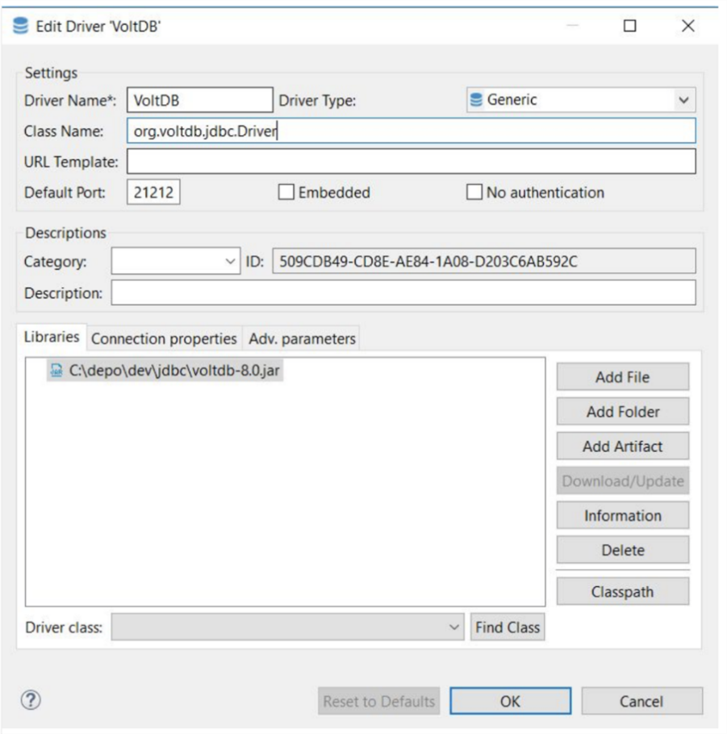

**DBeaver Connection Details**

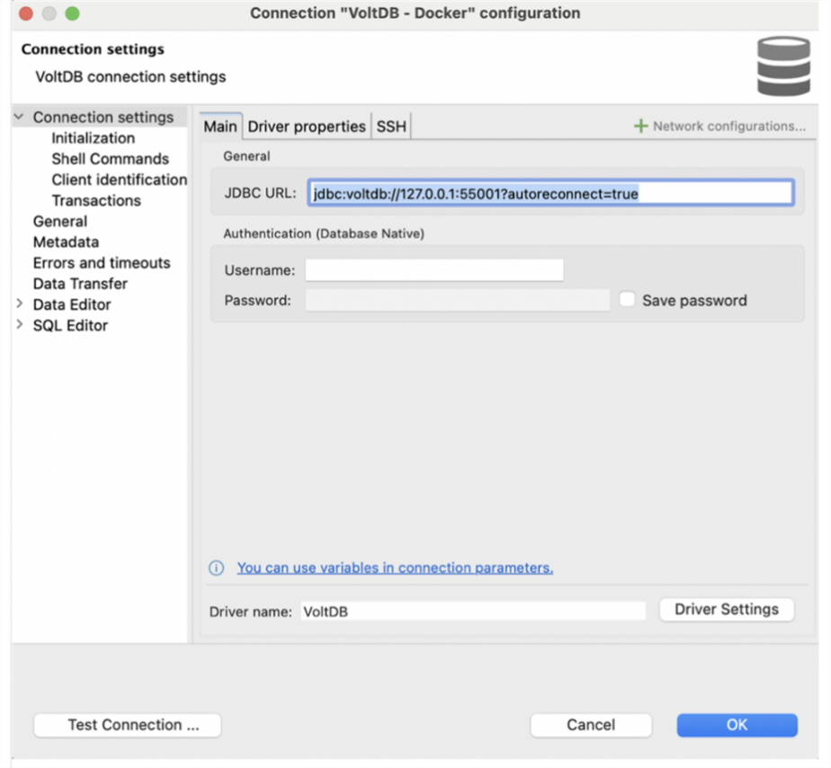

**VoltDB Management Center**

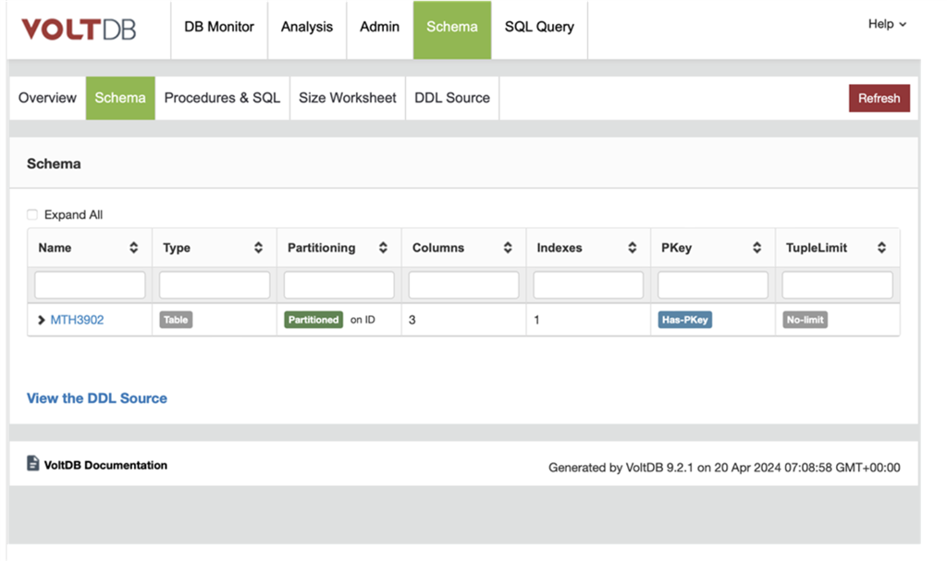

Please provide screenshots to show your work.

## VOLTDB-EX-03 Solution:

**Your Answer:**

